CFP 1 YEAR PYQ BTU [ CREDIT :- PRINCE CHOUHAN]
SEC A (VERY SHORT TYPE ) 2M
- EXPLAIN THE CONCEPT OF ARRAYS IN C ?
ANS: An array in C is a collection of elements of the same type stored in contiguous memory locations, accessed using indices, and declared with syntax like `int arr[5];`.
- WHAT IS PSEUDO CODE ?
ANS: Pseudo code is a simplified, informal way of describing a program's logic using plain language, resembling code structure but without syntax rules of actual programming languages.
- GIVE 4 EXAMPLES OF SECONDARY MEMORY ?
ANS: 1. Hard Drive
2. Solid State Drive (SSD)
3. USB Flash Drive
4. CD/DVD

- SUPPOSE A SYSTEM HAVE TWO VARIABLES . DRAW A FLOW CHART IDENTIFYING THE VARIABLE WHICH CONTAINS HIGHEST NUMBER . (NO EXPLAINATION REQUIRED)
ANS: 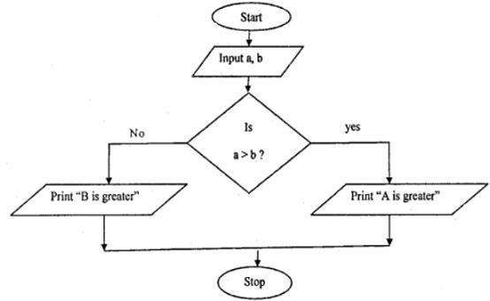
- IDENTIFY ERRORS PRESENT IN THE PROGRAM . IF YOU FIND THIS PROGRAM IN ORDER THEN WHAT WILL BE THE THE OUTPUT ? JUSTIFY YOUR ANSWER IN 25 WORDS .

- int main()
{
int a[]={10,20,30,40,50};
int j ;
for(j=0;j<5;j++)
{
printf(“%d\n”*(a+j));
}
}
ANS:

Output: 10
20
30
40
50
The program prints each array element in a new line.

- int main()
{
int a=12 , b=13;
if(a=b)
printf(‘a and b are equal’);
else
printf(‘a and b are not equal’);
}
ANS:
Error: Assignment operator ‘=’ used instead of comparison operator ‘= =’.
int main() {
int a = 12, b = 13;
if (a == b)
printf("a and b are equal");
else
printf("a and b are not equal");
return 0;
}
Output Justification: a and b are not equal
- CONVERT (255)₁₆ = (?)₁₀
- CONVERT USING DIRECT CONVERSION METHOD (1234)₈ = (?)₂ ₌ (?)₁₆
- CONVERT (9896)₁₀ =(?)₁₆

- WHAT IS DIFFRENCE BETWEEN CONSTANT AND VARIABLE ?
ANS:
ASPECT | CONSTANT | VARIABLE
DEFINATION | A value that does not change | A named storage that can change
DECLERATION | Declared with const keyword | Declared without const keyword
USAGE | Used for fixed values | Used for data that changes
MUTABILITY | Immutable (cannot change) | Mutable (can change)
INITIALIZATION | Must be initialized at declaration | Can be initialized later
EXAMPLE | const int MAX_VALUE = 100; | int count = 0;

- WRITE THE NOTATIONS OF FLOW CHART ?
ANS: • Terminal/Start/End: Oval shape used to indicate the beginning or end of a process.

• Process: Rectangle with rounded corners used to represent a task or operation.

• Input/Output: Parallelogram shape used to represent data input or output.

• Decision: Diamond shape used to represent a decision point, with arrows branching out based on conditions (usually yes/no or true/false).

• Flow Arrow: Arrows connecting the symbols to show the flow or sequence of operations
- PERFORM (10101)₂-(01110)₂
- FIND OUTPUT OF THE FOLOWING PROGRAM WITH VALID REASON .
#include<stdio.h>
void main()
{
static int var=5;
print f(“%d”,var--);
if(var)
main();
}
OUTPUT: 5 4 3 2 1
REASON : • here static keyword ensures that var retains its value between function calls.
• The printf statement prints var each time main() is called.
• The recursive call continues until var becomes 0, printing each value of var from 5 down to 1 in sequence.
SOME EXTRA QUESTIONS :
Unit 1: Fundamentals of Computer

1. Define "Stored program architecture of computers."
- Stored program architecture refers to a design where instructions and data are stored in the same memory, allowing for sequential execution and easy modification of programs.

2. What is meant by "Random, Direct, Sequential access methods" in the context of storage devices?
- These methods describe how data is accessed from storage devices. Random access allows immediate retrieval, sequential access reads data sequentially, and direct access retrieves data using specific addresses.

3. Explain the concept of "High-level, Assembly, and Low-level languages" with examples.
- • High-level languages (e.g., Python, Java) are user-friendly and abstracted from hardware.
• Assembly language (e.g., x86) is closer to machine code and uses mnemonics.
• Low-level languages (e.g., machine code) directly control hardware and are not user-friendly.

4. Define "Hardware, Software, Firmware" in the context of computing systems.
- • Hardware refers to physical components like CPU and memory.
• Software includes programs and applications that run on hardware.
• Firmware is software embedded into hardware devices, providing low-level control and functionality.
5. What is the difference between a "Source file" and an "Object file" in programming?
- • A source file contains code written by a programmer in a high-level language.
• An object file is the compiled output of a source file, ready for linking with other object files to create an executable program.
- A source file contains human-readable code, while an object file is a compiled version ready for linking with other modules or libraries.

6. Define "Assembler, Compiler, Interpreter" and explain their roles in software development.
- • Assembler converts assembly language code into machine code.
• Compiler translates high-level language code into machine code once, producing an object file.
• Interpreter translates and executes high-level code line-by-line, without producing a separate executable.

Unit 2: Number System

1. Define "Data representations" in the context of number systems.
- Data representations refer to methods of encoding data (e.g., integers, characters) into binary form for processing by computers.

2. What is meant by "Radix" and how is it used in number representations?
- Radix (base) denotes the number of unique digits, influencing how numbers are represented (e.g., binary base-2, decimal base-10).

3. Explain "r's and (r-1)'s complement" with respect to number systems.
- • r's complement is used for subtraction in binary systems.
rs complement= r^{n}−N
where r is the base of the number system, n is the number of digits in the number, and N is the integer for which the complement is sought.
• (r-1)'s complement corrects the overflow in r's complement arithmetic.
(rs-1) complement= (r^{n}−1)−N
where r is the base of the number system, n is the number of digits in the number, and N is the integer for which the complement is sought.

4. What are the different representations of alphabets in computing?
- Alphabets can be represented using character encoding systems like ASCII or Unicode, converting characters into binary form for processing.

Unit 3: C Language

1. Define the "C character set" and list its components.
- The C character set includes letters, digits, and special characters used in C programming, defining the syntax and structure of programs.
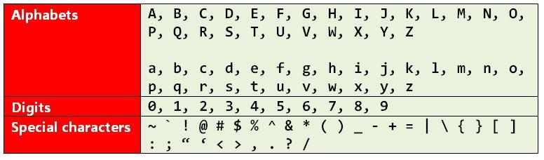

2. Explain "Data types in C" and provide examples of each.
- Data types in C specify the type of data that a variable can hold. They define the size and type of values that can be stored in variables, allowing the compiler to allocate memory and interpret the data correctly during program execution.
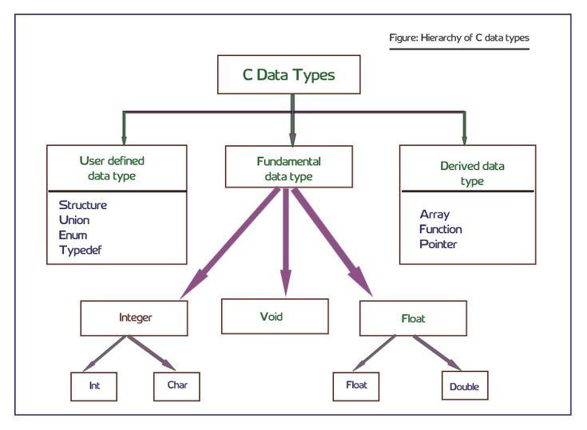

3. Define "ASCII Code" and its significance in programming.
- ASCII (American Standard Code for Information Interchange) is a character encoding standard that assigns numeric values to characters, facilitating their representation in digital systems.

4. What is the purpose of "Formatted input-output statements" in C programming?
- These statements in C control the format of data displayed on the screen (output) or read from the user (input), ensuring data is presented or accepted in the desired manner.

5. Define "Operators" in C and categorize them based on their types.
- Operators in C are symbols that perform operations on variables and values, facilitating tasks like arithmetic, logical comparisons, assignment, and more complex manipulations within expressions and conditions.
C provides operators like arithmetic (+, -, *, /), relational (>, <, ==), logical (&&, ||), bitwise (&, |), and assignment (=), each serving specific purposes in expressions and conditions.

6. Explain "Expression Evaluation" and the rules governing it in C.
- Process of computing values of expressions following rules of operator precedence and associativity in C, ensuring accurate and predictable program behavior.

Unit 4: Control Statement and Loop in C

1. Define "Control Statement" and explain its role in programming.
- Control statements in C alter the flow of program execution based on specified conditions, ensuring decisions are made and actions are taken accordingly.

2. What are the different types of "Control Statements" in C? Provide examples.
- • Conditional statements (if, else if, else) execute code based on conditions.
• Looping statements (for, while, do-while) repeat code until conditions are met.
• Switch statement selects from multiple alternatives based on a value.

3. Define "Looping and Iteration" and explain its importance in programming.
-Looping and iteration in programming are crucial for automating repetitive tasks, enhancing code efficiency by reducing redundancy, providing flexibility in handling varying data sizes, and enabling complex algorithm implementation. They ensure accurate and consistent task execution while improving code readability and maintainability..

4. Define "Conditional Operator" and explain its usage in C programming.
- ?: Evaluates a condition, executing one of two expressions based on whether the condition is true or false, compactly handling conditional expressions.

Unit 5: Arrays, Pointers & Structure in C

1. Define "Arrays" in C and explain their role in storing multiple data elements.
- Arrays in C are collections of elements of the same data type stored in contiguous memory locations, accessed using indices to retrieve or modify data efficiently.

2. What are "Pointers" in C? How are they used in programming?
- Pointers are variables that store memory addresses of other variables. They are used for dynamic memory allocation, accessing array elements, and improving performance in certain operations.

3. Define "Structures and Unions" in C. Explain their differences and similarities.
- • Structures group different data types together under a single name, allowing for the creation of complex data structures.
• Unions allow storage of different data types in the same memory location, useful for saving memory when only one value is needed at a time.

4. What is the significance of "Enumeration" in C programming?
- Enumeration defines a set of named constants representing integer values, improving code readability by replacing magic numbers with descriptive identifiers.

5. Define "Functions in C" and explain their types and uses in programming.
- Functions in C are modular blocks of code that perform specific tasks. They can be standard library functions or user-defined functions, promoting code reusability and organization.

Unit 6: Input and Output

1. Define the "Concept of a file" and explain its importance in handling data.
- A file in C is an abstract representation of data stored on a storage device. It allows programs to read from or write to external storage, facilitating data persistence and management.

2. What are "Text files and Binary files" in the context of file handling?
- • Text files store data as plain text characters readable by humans.
• Binary files store data in binary format, which is readable only by the computer, often used for efficiency and data integrity in complex applications.

3. Explain "Opening and Closing files" in C programming.
- Opening files establishes a connection between the program and the file, allowing data access. Closing files terminates this connection, ensuring proper resource management and data integrity.

4. Define "File input/output functions" and list some standard library functions for file operations.
- Standard library functions (e.g., fopen, fclose, fread, fwrite) facilitating file operations like reading and writing data, ensuring robust file interaction in programs.

5. Explain "File status & Positioning functions" and their usage in file handling.
- Functions retrieving file information (e.g., file size) and manipulating current file position for reading or writing operations, optimizing file processing and management.
SEC B (SHORT TYPE ) 8M
- CALCULATE 9’s COMPLIMENT OF 74895.

- SUBTRACT (7657)₈ FROM (863C)_{16 .}

- SUBTRACT USING 2’s COMPLIMENT METHOD FOLLOWING STEP AS SHOWN IN BELOW . (S1) CONVERT TO BINARY (S2) SUBTRACT USING 2’s COMPLIMENT (S3) FIND MAGNITUDE IN DECIMAL .
A] 49-25 B] 101-115
- WRITE r’s COMPLIMENT OF FOLLOWING NUMBERS, WHERE r IS radix (BASE) OF THOSE NUMBERS .
- (10111010)₂
- (34056)₈
- (8750)₁₀
- (7f3b)₁₆

- DRAW A FLOW CHART TO ADD 2 NUMBERS WRITTEN AS (a/b) and (c/d).

- STATE THE DIFFRENCE BW A] ASSEMBLY AND MACHINE LEVEL LANGUAGE , B] STRUCTURE AND UNION WITH SUITABLE EXAMPLES.
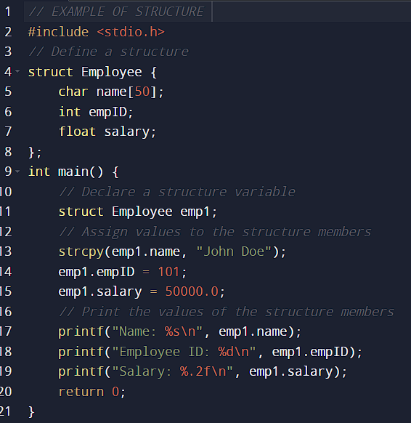
ANS: 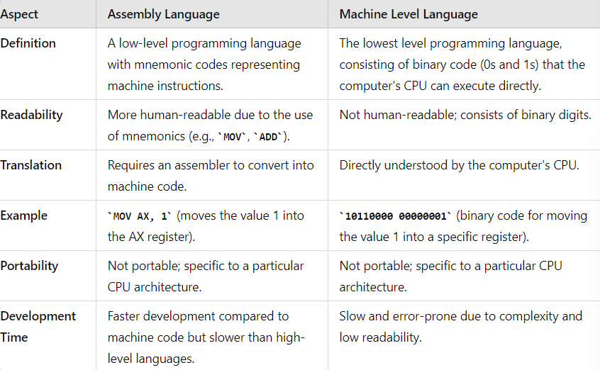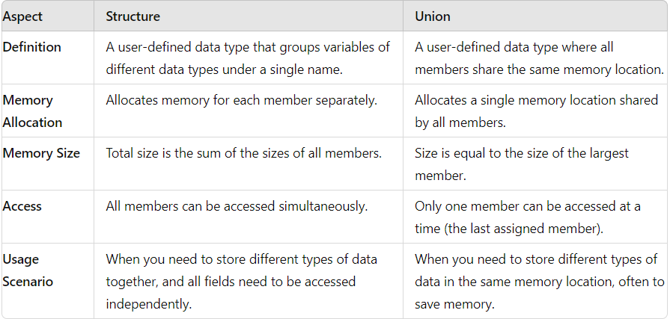 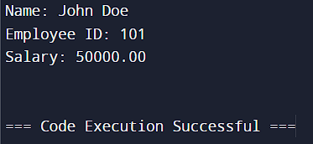
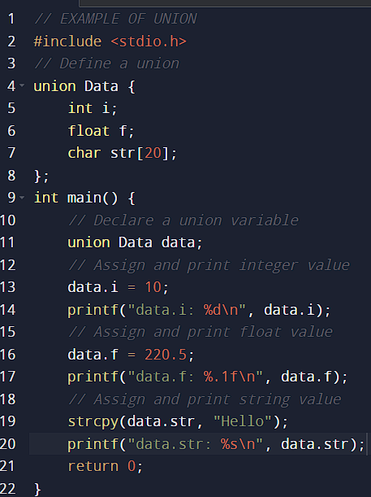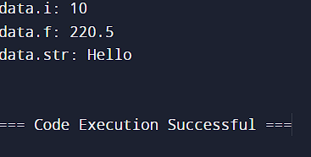
- WHAT DO YOU UNDERSTAND BY MULTIFILE HANDALING . GIVE A SUITABLE EXAMPLE .
ANS: Multifile Handling in C involves dividing a program into multiple files to manage large codebases efficiently. This practice separates declarations and definitions, typically using header files for declarations and source files for definitions.
Multifile handling enhances code organization, modularity, readability, and reusability.

- WHAT IS STORED PROGRAM ARCHITECTURE (VON NEUMANN ARCHITECTURE) OF COMPUTER ? DRAW THE ARCHITECTURE BLOCK DIAGRAM . BRIEFLY DESCRIBE EACH COMPONENT AND THEIR INTERCONNECTIONS .
ANS: Stored Program Architecture, also known as the von Neumann architecture, is a computer design model that uses a single storage structure to hold both instructions and data. This architecture is fundamental to the operation of most computers today.
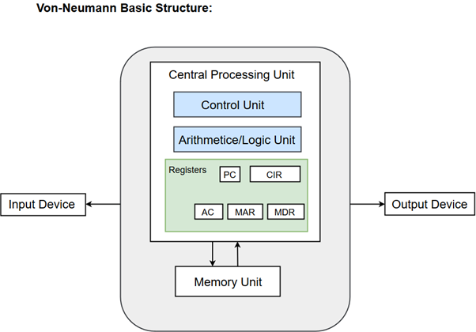
CPU (Central Processing Unit): The part of the Computer that performs the bulk of data processing operations is called the Central Processing Unit and is referred to as the CPU.
The Central Processing Unit can also be defined as an electric circuit responsible for executing the instructions of a computer program.

- ALU (Arithmetic Logic Unit): Executes arithmetic and logical operations.
- Registers: Small, fast storage locations within the CPU used to hold data temporarily during processing.
- CU (Control Unit): Manages and coordinates all activities within the CPU and controls data flow between the CPU, memory, and I/O devices.
Memory (Primary Storage): Stores both the program instructions and the data that the program operates on.
- RAM (Random Access Memory): Stores data and instructions temporarily during program execution. It is directly accessible by the CPU.
- Cache: Provides faster access to frequently used data, reducing the average time to access memory.
Input/Output (I/O) Devices: Allow the computer to interact with the external environment and users.
- Input Devices: Devices like keyboards, mice, and scanners used to input data into the computer.
- Output Devices: Devices like monitors, printers, and speakers used to output data from the computer.
System Bus: A communication pathway that connects the CPU, memory, and I/O devices, allowing them to exchange data.
- Data Bus: Transfers data between the CPU, memory, and I/O devices.
- Address Bus: Carries memory addresses from the CPU to other components to specify where data should be read from or written to.
- Control Bus: Carries control signals from the CPU to other components to coordinate operations.
- DRAW A FLOW CHART THAT READ N NUMBERS AND ALSO CALCULATE THE AVERAGE OF THESE N NUMBERS . WRITE AN ALGORITHUM FOR SAME.

- WHAT IS 2-D ARRAY ? WRITE A PROGRAM TO MULTIPLY TWO MATRICES A AND B OF SIZE 3x3 EACH AND STORE RESULT IN MATRIX C .
ANS: A 2-D array (two-dimensional array) is an array of arrays. It can be visualized as a table with rows and columns, where each element is identified by two indices: the row index and the column index.
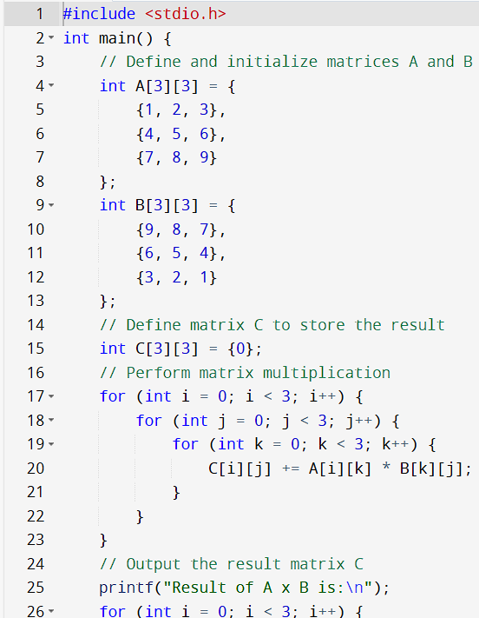
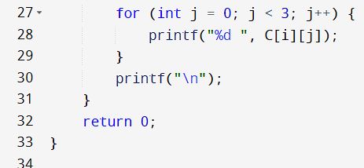
- WRITE A PROGRAM TO DISPLAY THE FOLLOWING PATTERNS .
A
A B
A B C
A B C D
A B C D E
ANS: 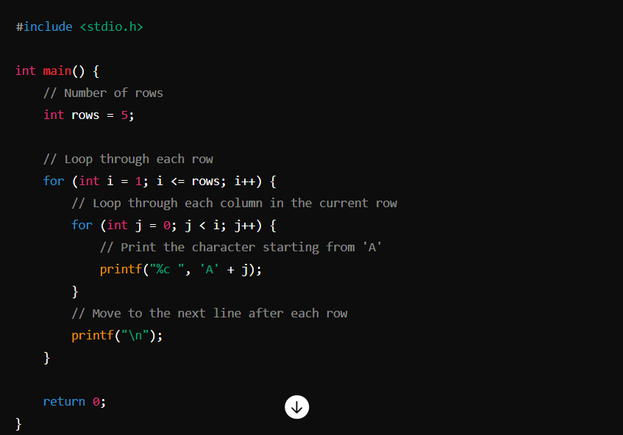

- WHAT IS POINTER VARIABLE ? EXPLAIN , WHY POINTER VARIABLE OF A PARTICULAR DATA TYPE CANNOT REFER TO VARIABLE OF ANOTHER DATA TYPE USING SUITABLE EXAMPLE ?
ANS: A pointer variable is a variable that stores the memory address of another variable. Pointers are used for dynamic memory allocation, passing data to functions by reference, and manipulating arrays and structures efficiently.
Explanation
A pointer variable of a particular data type cannot refer to a variable of another data type because each data type has a specific size and interpretation in memory. Using a pointer of one data type to refer to a variable of another type can lead to incorrect data access and undefined behavior.
Example
Consider the following example in C:
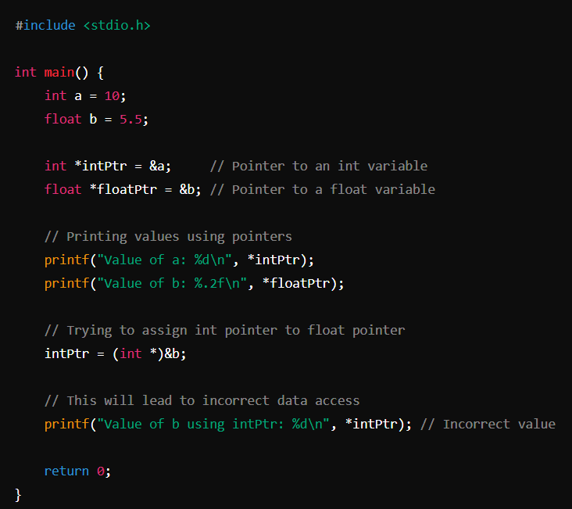

- WHAT IS POINTER ? EXPLAIN ARRAY OF POINTERS.
ANS: A pointer is a variable that stores the memory address of another variable. Pointers are used for dynamic memory allocation, efficient array manipulation, and for passing large structures or arrays to functions without copying the data.

Array of Pointers
Definition: An array of pointers is an array where each element is a pointer to a variable or another data structure. This allows for more flexible and dynamic data management, as each pointer in the array can point to different memory locations.

Explanation
An array of pointers can be useful in scenarios such as managing a list of strings or dynamic data structures. Here's an example to illustrate the concept.

Example

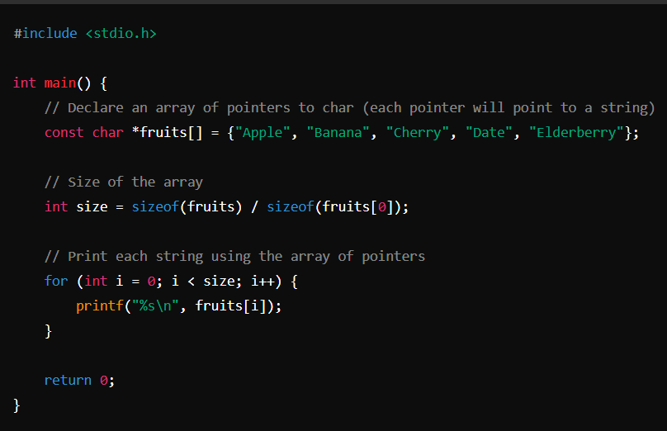

- WRITE A PROGRAM IN C AND MAKE A FLOW CHART TO FIND MAXIMUM AMONG 3 NUMBERS .
ANS:
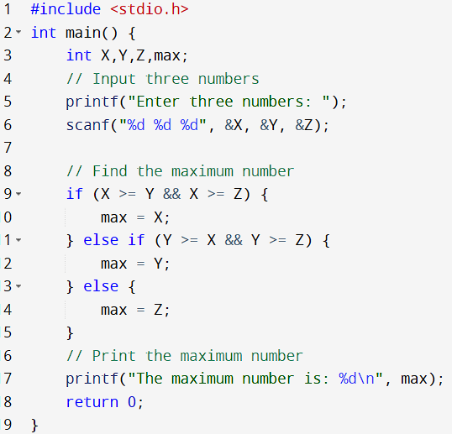
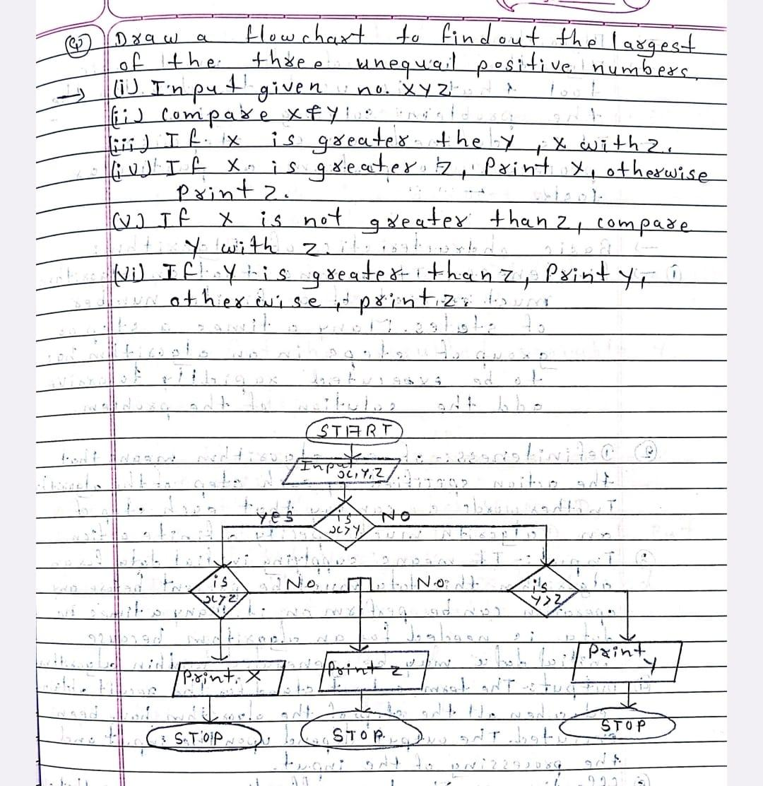

- WHAT ARE DATA TYPES IN C ? TYPES , EXPLAIN WITH EXAMPLES
ANS: Data types in C define the type and size of data that a variable can hold. They determine how much memory is allocated for the variable and what kind of operations can be performed on it.
Types of Data Types in C
- Basic (Primary) Data Types:
  - int: Used to store integers (whole numbers).
  - float: Used to store floating-point numbers (numbers with a decimal point).
  - double: Used to store double-precision floating-point numbers.
  - char: Used to store single characters. 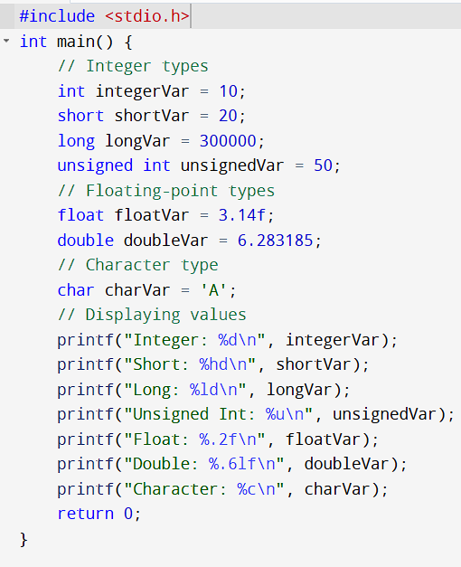
- Derived Data Types:
  - Array: Collection of elements of the same type.
  - Pointer: Stores the memory address of another variable.
  - Structure: Combines different data types into a single unit.
  - Union: Similar to structure but shares memory among its members.
  - Function: Blocks of code that perform specific tasks.
Enumeration Data Type:
  - enum: User-defined data type that assigns names to integral constants.
- CONTRAST BW PARAMETER PASSING IN A FUNCTION , ‘BY VALVE’ AND ‘BY REFRENCE’ ?
ANS: 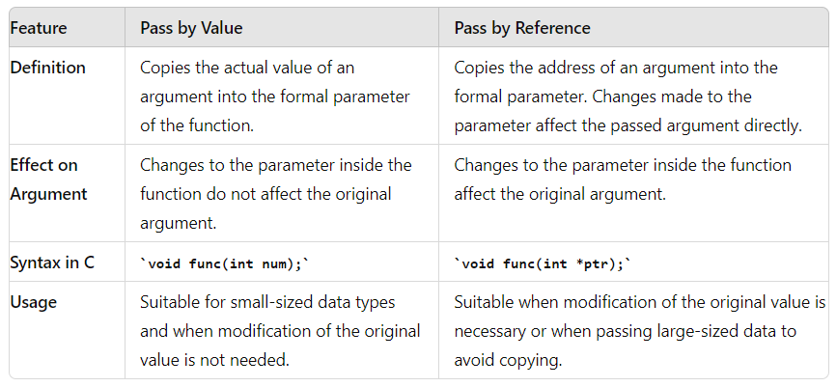
- WHAT DO YOU MEAN BY STORAGE DEVICES? EXPLAIN THE CONCEPTS OF HIGH LEVEL, ASSEMBLY AND LOW LEVEL LANGUAGES ?

ANS: Storage Devices: Storage devices are hardware components that store data temporarily or permanently in a computer system. They include:
- Primary Memory: Immediate storage directly accessible by the CPU, such as RAM (Random Access Memory).
- Secondary Storage: Persistent storage used for long-term data retention, such as hard drives, SSDs (Solid State Drives), and optical discs.
High-level, Assembly, and Low-level Languages:
- High-level Languages:
  - Definition: High-level languages are designed for ease of human understanding and readability. They use natural language constructs and are independent of the underlying hardware architecture.
  - Examples: Python, Java, C++, and JavaScript.
  - Characteristics: Abstraction from hardware details, rich libraries, and support for complex data structures and algorithms.
- Assembly Language:
  - Definition: Assembly language is a low-level programming language that provides a symbolic representation of machine code instructions.
  - Examples: x86 assembly, ARM assembly.
  - Characteristics: Directly corresponds to machine instructions, uses mnemonic codes for operations, and requires understanding of computer architecture.
- Low-level Languages:
  - Definition: Low-level languages are closer to machine code and hardware. They offer minimal abstraction from the computer's architecture.
  - Examples: Machine language (binary code directly executable by the CPU), and assembly language.
  - Characteristics: Directly manipulates hardware resources, requires detailed knowledge of CPU architecture, and provides fine-grained control over system resources.
- WHAT IS TYPE CASTING ?
ANS: Type casting in programming refers to the process of converting one data type into another. It allows you to explicitly change the data type of a variable or an expression to suit the requirements of a specific operation or context.
Key Points about Type Casting:
- Purpose: Type casting is used when you want to treat a variable of one type as another type temporarily or permanently.
- Syntax: In C and similar languages, type casting is typically done by placing the desired data type in parentheses before the variable or expression to be converted.
- Example:
float num1 = 10.5;
int num2 = (int)num1; // Casting float to int

SEC C (LONG TYPE) 13M
- EXPLAIN THE DIFFRENCES AMONG DIRECT , SEQUENTIAL AND RANDOM ACCESS METHODS .

ANS: Direct Access Method:
- Definition: Direct access allows data to be retrieved directly from any location on the storage device without needing to traverse the intervening space.
- Usage: Typically used in storage devices like hard drives and SSDs where data is accessed randomly using physical addresses.
- Example: Accessing a specific sector on a hard drive using its sector number without having to read through all preceding sectors.
Sequential Access Method:
- Definition: Sequential access involves accessing data in a linear sequence, starting from the beginning and proceeding step by step to the desired location.
- Usage: Commonly used in tape drives or streaming media where data is read or written sequentially.
- Example: Reading a tape where each subsequent piece of data can only be accessed after the previous one.
Random Access Method:
- Definition: Random access allows data to be retrieved from any location in constant time regardless of its sequential order.
- Usage: Essential for fast data retrieval in primary memory (RAM) and some secondary storage devices like flash memory.
- Example: Accessing an element in an array where each element can be accessed directly by its index.
Differences:
- Access Speed:
  - Direct Access: Fast, as it allows immediate retrieval of data from any location.
  - Sequential Access: Slower compared to direct access, especially when accessing data far from the current position.
  - Random Access: Fast, similar to direct access, due to the ability to access any location directly.
- Data Retrieval Pattern:
  - Direct Access: Non-sequential; data can be accessed in any order.
  - Sequential Access: Sequential; data is accessed in the order it is stored.
  - Random Access: Non-sequential; data can be accessed in any order based on index or address.
- Applications:
  - Direct Access: Used in databases, virtual memory systems, and indexed files.
  - Sequential Access: Used in tape drives, reading logs, and sequential data processing.
  - Random Access: Used in primary memory (RAM), flash drives, and indexed storage systems.
- WRITE A PROGRAM TO ADD THE CONTENTS OF 2 ARRAYS USING POINTER .
ANS:
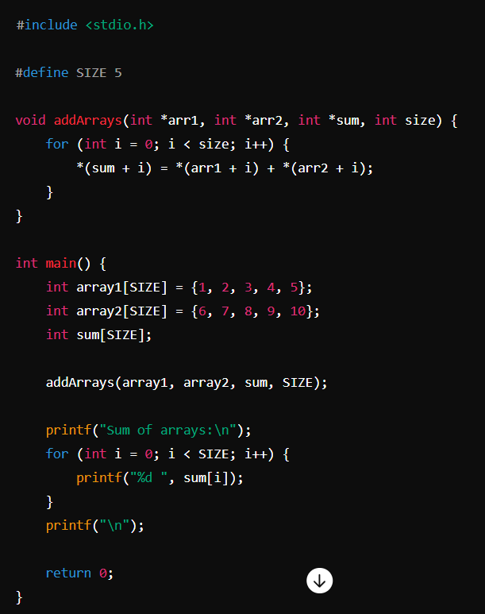

- EXPLAIN FEATURES OF ASSEMBLY LEVEL , LOW LEVEL AND HIGH LEVEL LANGUAGES IN COMPARATIVE MANNER .
ANS:
- Assembly Level Language: Directly represents machine code, optimal for system-level programming.
- Low-Level Language: Balances hardware access with abstraction, efficient and moderately portable.
- High-Level Language: Maximizes productivity with abstraction and portability, focusing on application development.
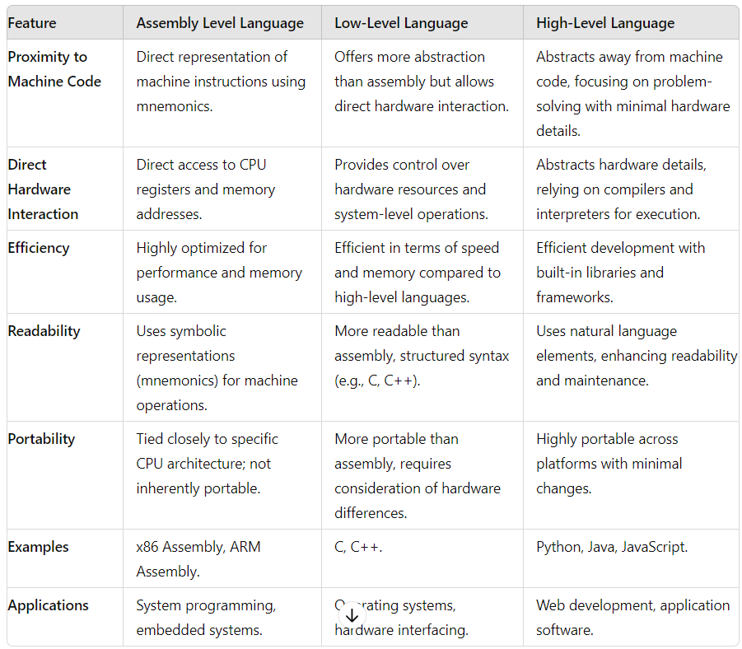
- EXPLAIN THE DIFFRENCE BW STRUCTURES AND UNIONS IN C . WRITE A C PROGRAM TO READ THE STUDENT NAME , ROLL NO AND MARKS OF THREE SUB AND DISPLAY THE SAME USING STRUCTURES IN C .
ANS:
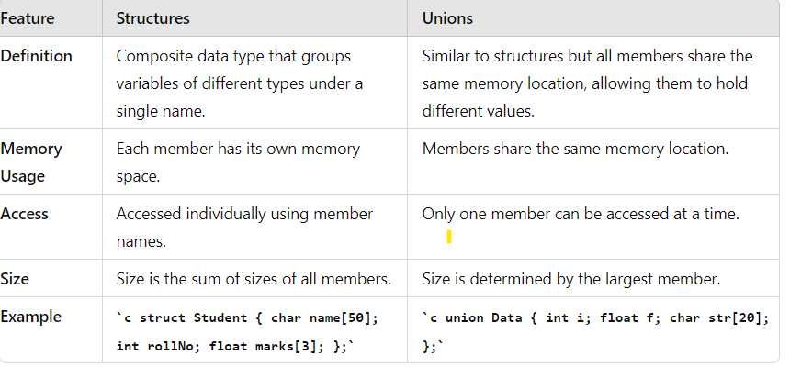
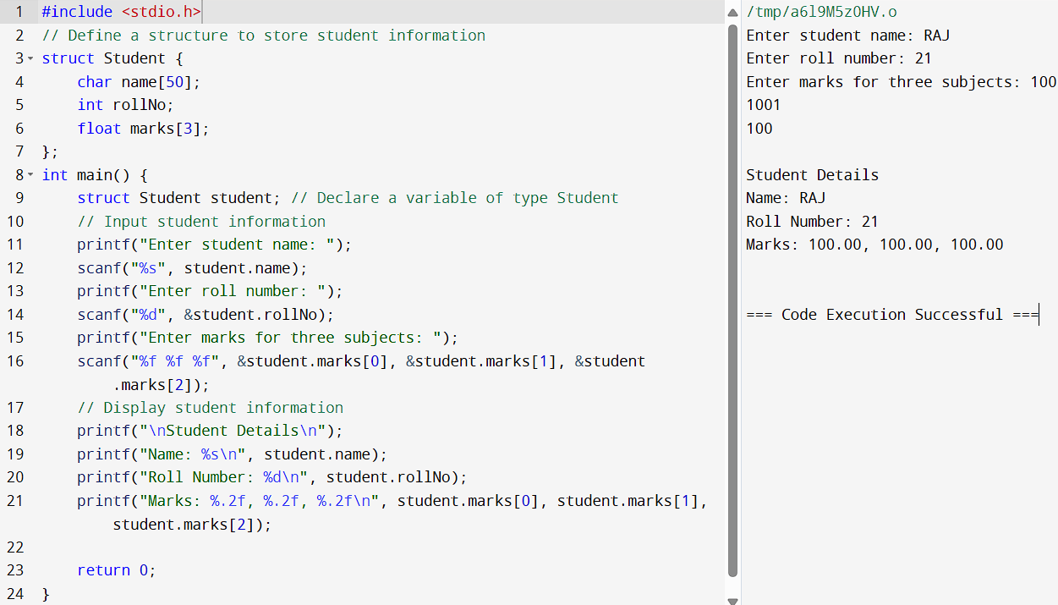

- EXPLAIN FOLLWING – (USE SUITABLE EXAMPLES AS NEEDED)
- BREAK STATEMENT
- PARAMETER PASSING IN FUNCTION
- FILE HANDLING IN C LANGUAGE

a) Break Statement
The break statement in C is used to exit from a loop or switch statement prematurely. It is typically used to terminate the execution of the innermost loop or switch case without completing its entire iteration or execution.
Example:

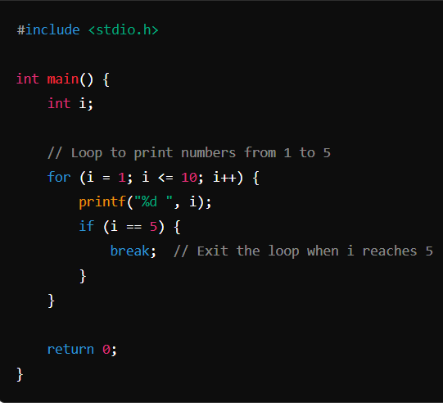

b) Parameter Passing in Function
Parameter passing in C refers to how arguments are transferred from the caller (where the function is called) to the callee (the function being called). There are two main methods of parameter passing:
- Pass by Value: In this method, a copy of the actual parameter's value is passed to the function. Changes made to the parameter inside the function do not affect the original value outside the function.
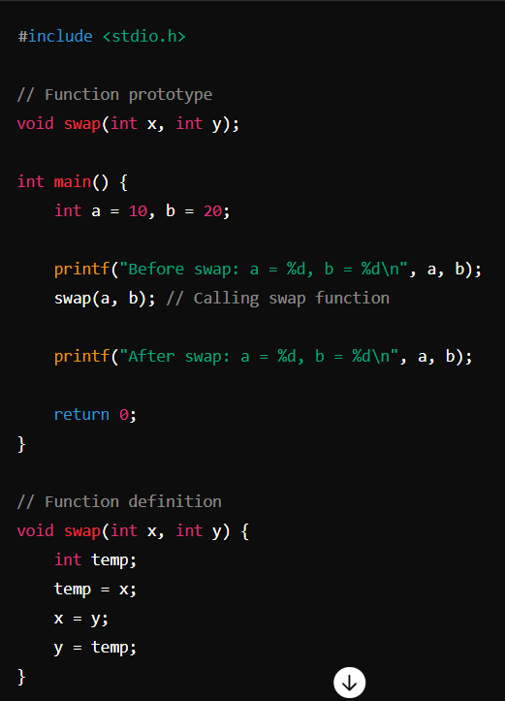
Pass by Reference: This method allows the function to modify the actual parameter by passing its address. Changes made to the parameter inside the function affect the original value.
Example:
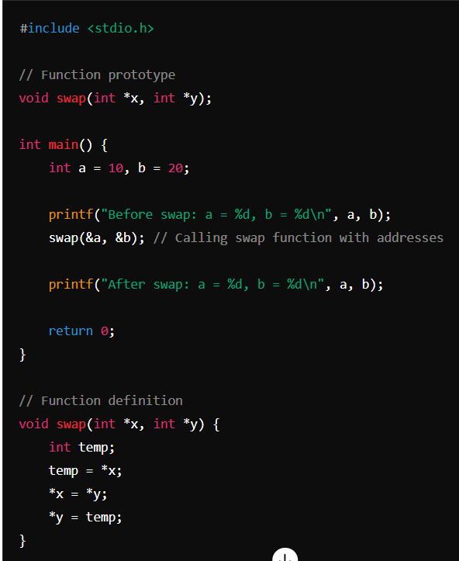

c) File Handling in C Language
File handling in C involves operations related to reading from and writing to files on a storage device. It allows programs to interact with external files to store and retrieve data.
Example:
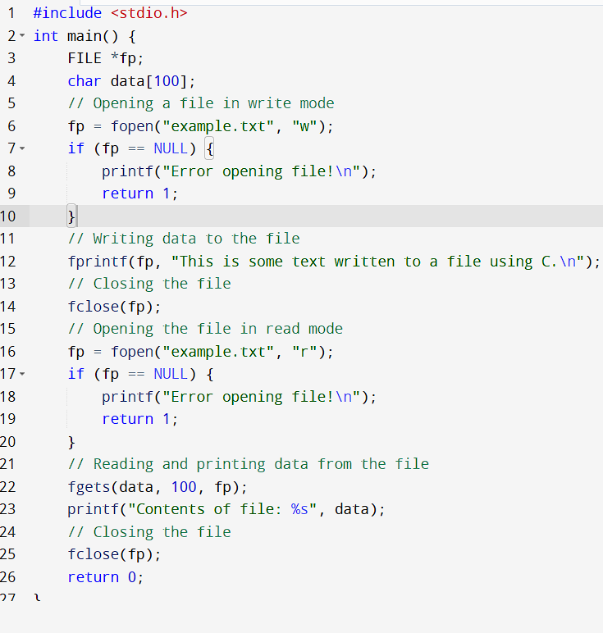
- WRITE A C PROGRAM TO READ CONTENTS OF A FILE AND DISPLAY THEM IN UPPER CASE .
ANS: 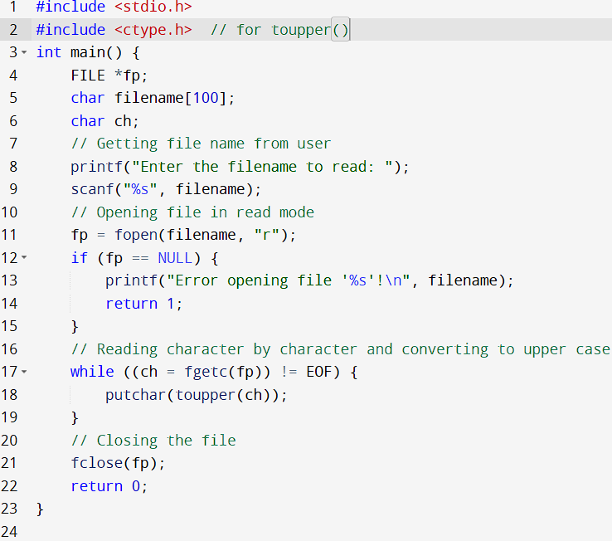

- WHAT DO YOU MEAN BY RANDOM , DIRECT AND SEQUENTIAL ACCESS METHODS ? EXPLAIN STORED PROGRAM ARCHITECTURE OF COMPUTERS
ANS: Random Access Method:
- Definition: Allows direct access to any storage location using an address.
- Example: In arrays or memory, where elements can be accessed directly by their index or address without traversing through other elements.
Direct Access Method:
- Definition: Provides direct access to data blocks on a storage device through their physical location.
- Example: Accessing specific sectors on a hard disk using their physical sector numbers.
Sequential Access Method:
- Definition: Data is accessed sequentially, one after the other, from the beginning to the end.
- Example: Reading a text file where data is accessed in the order it was written, without random access capabilities.
- WHAT IS ARRAY AND ITS TYPE ? EXPLAIN ARRAY OF STRUCTURES WITH THE HELP OF SUITABLE PROGRAM ALSO DESCRIBE STRUCTURE WITHIN STRUCTURE WITH AN EXAMPLE
ANS: Array Definition:
- An array in C is a collection of elements of the same data type stored in contiguous memory locations.
- It allows storing multiple values under a single name, accessed by index.
Types of Arrays:
- One-Dimensional Array:
  - Stores elements in a linear sequence.
  - Example: int arr[5]; declares an array arr that can hold 5 integers.
- Two-Dimensional Array:
  - Represents a table of rows and columns.
  - Example: int matrix[3][3]; declares a 3x3 matrix where each element is an integer.
- Multi-Dimensional Array:
  - Arrays with more than two dimensions.
  - Example: int cuboid[2][3][4]; declares a 3D array representing a cuboid.
Array of Structures: An array of structures is an array where each element is a structure.
- Each structure can hold different types of data related to a single entity.
Example Program:
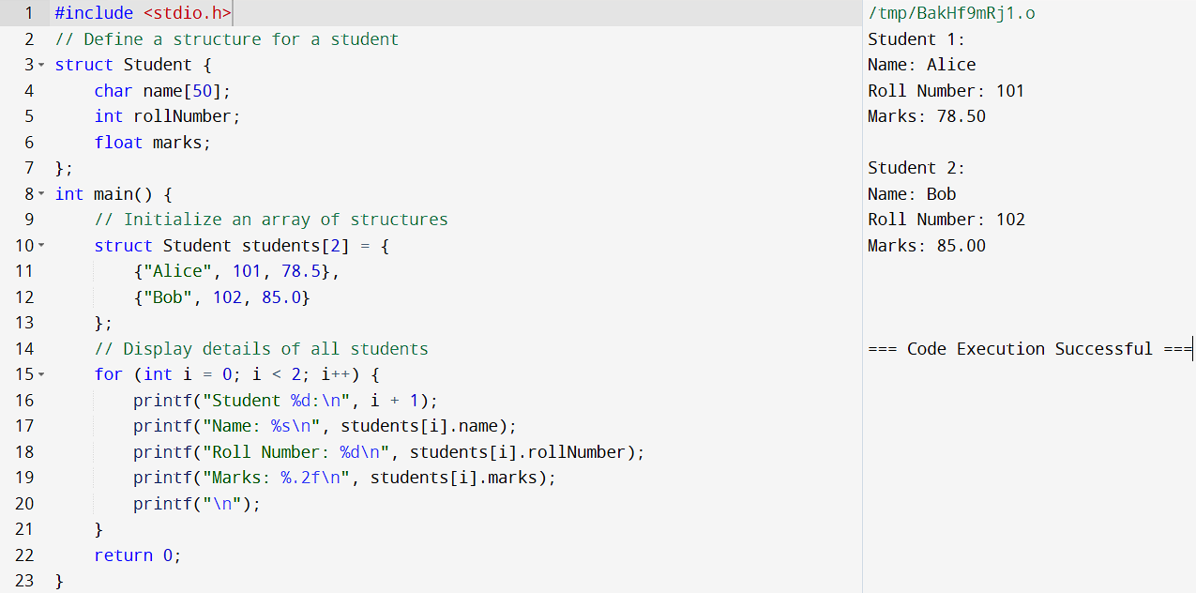
Structure Within Structure: A structure within a structure (nested structure) allows defining a structure member that itself is another structure.
Example:
